Company Name
Lean Canvass Business Plan
Date
Company Address
City, State, Zip
Phone Number:
Fax Number:
Email:
Web site:
Contact Person:
Table of Contents
Lean Canvas 3
Product 5
1: Problem 5
3: Solution 5
6: Key Metrics 5
Pirate Metrics 5
Customer Metrics 6
North Star Metric 6
5: Cost Structure 7
Cost Curve 7
Value Metrics 7
2: Unique Value Proposition 9
Simpson’s Paradox 9
Market 11
7: Unfair Advantage 11
4: Channels 11
1: Customer Segments 11
5: Revenue Stream 12
Increase LTV 12
The Abbreviations 12
The Formula 12
Usage 12
Revenue Status 13

Lean Canvas
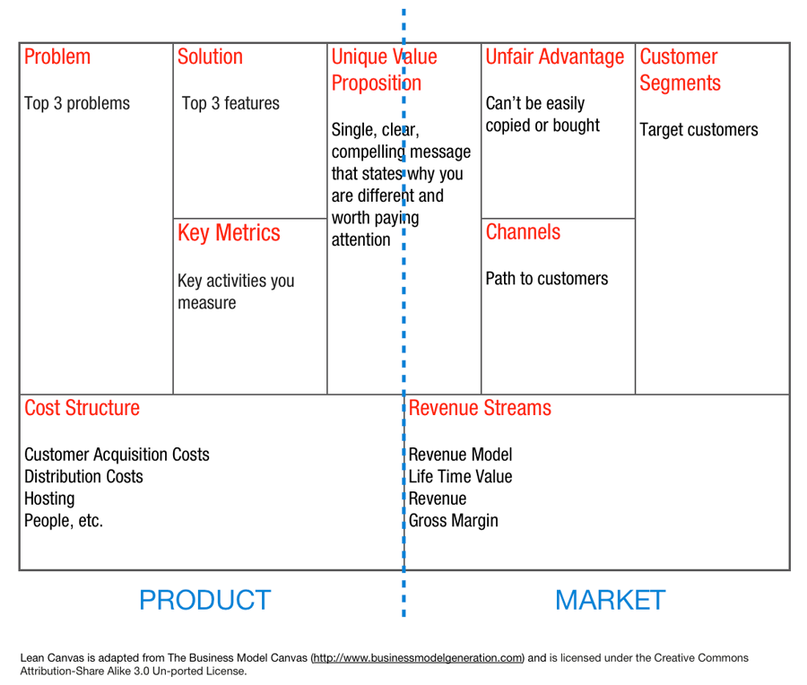
Numbers correlate with the order in which the sections are to be completed.

Product

1: Problem
List three problems you are trying to solve:
- Problem # 1;
- Problem # 2;
- Problem # 3;

3: Solution
List the top three features of your solution:
- Feature # 1;
- Feature # 2;
- Feature # 3;

6: Key Metrics
What are the key activities that you measure?

- Eyeballs are for exposure, brand, and PR;
- Customers are for paying the bills.;

Pirate Metrics

Measure metrics that correlate with the customer’s true needs;

- Acquisition;
- Optimize Acquisition;
- Track Acquisition strategies;
- Segment users by how acquired;
- Pay attention to your analytics;
- Activation;
- Speed up activation;
- Segment users;
- Funnel for a Quicker Aha! Moment;
- How many potential customers are not being activated properly;
- Where are those customers getting lost;
- What steps need to be taken to fix it;
- Retention;
- Retention is king;
- Churn is Public Enemy # 1;
- Churn is industry specific;
- Using 90% as industry average is not a bad starting point;
- Referral;
- Can you build a referral machine;
- How many eyeballs did the referrals bring;
- How many customers did the referrals bring;
- K-Factor Results;
- K-Factor < 0.00: Lots of room for improvement;
- K-Factor = [0.00 … 0.05]: Poor;
- K-Factor = [0.05 … 0.15]: Average;
- K-Factor = [0.15 … 0.25]: Good;
- K-Factor = [0.25 … 0.50]: Great;
- K-Factor = [0.50 … 0.75]: Outstanding;
- K-Factor = [0.75 … 1.00]: Rocket Fuel;
- K-Factor > 1.0: Viral Growth. Extremely rare to hit, even temporarily;
- K-Factor > 2.0: Fabricated data;
- Revenue;
- Value > Cost = $$ + Time + Focus;
- Marketing to those who don’t give you the kind of value you want;
- Spending too much/not enough on marketing and acquisition;
- Set an LTV:CAC ratio of at least 3:1:
- LTV/CAC < 1.0: Not sustainable;
- LTV/CAC = [1.0 … 2.0]: Sustainable;
- LTV/CAC = [2.0 … 3.0]: Good;
- LTV/CAC = [3.0 … 4.0]: Great;
- LTV/CAC > 4.0: Outstanding;
- Fixing Revenue Issues;
- Funnel optimization;
- Pricing optimization;
- Engagement optimization;

Customer Metrics

- The process is centred around your relationship with a recognized need;
- Your relationship with need goes back to before the company came on the scene, and continues after the company dies;

North Star Metric

The single metric that reflects where your product is today.
- Experience with the product:
- Beginner: In the early stages of your product, focusing on upping your total active user base is perfectly acceptable;
- Intermediate: As you hone your approach to data, look for more specific levers of growth. For an analytics product, this would be something like getting users to create 3 reports;
- Advanced: When you get more at home with your analytics data, you can start using a secondary metric to supplement your core metric. As you have multiple product teams, you can have each of them devoted to upping other specific core metrics.
- Becoming a Habit;
- Set an expiration date, by which the activity is to occur;
- Tape your core metric to the heads of the entire team;
- Drown out the noise;
- Move beyond blind data;
- Use data to challenge assumptions;
- Use data to validate hypotheses;

5: Cost Structure
Customer acquisition costs
Distribution costs;
Hosting Cost;
People, etc.

Cost Curve

- Cost + profit;
- Competitor pricing;
- Subjective value;
- Objective value;
- Perceived value;

Value Metrics

- Does your value metric align to customer needs;
- Is the value metric easy to understand;
- Does the value metric grow with the customer;

2: Unique Value Proposition
This is a single, clear, compelling messages that states why you are different, and worth buying.

What are the existing alternatives to the products you offer?

How do potential customers currently solve the problem that your product solves?

What is your finished story benefit?

Pick the words carefully, and own them.

The UVP contains the who, what, and, ideally, why (for what reason).

Simpson’s Paradox

Your solution increases the problem, rather than reduces it.

Market

7: Unfair Advantage
Can’t be easily copied or bought.

4: Channels
This is your path to your customers.

Inbound channels:
- Blogs;
- SEO: Search Engine Optimisation;
- eBooks;
- White papers;
- Webinars;

Outbound channels:
- SEM: Search Engine Marketing;
- Print Adds
- TV Adds;
- Trade shows;
- Cold calling;

Direct sales:
- You hire people to sell the product;

Automated sales:
- Other people beg to sell your product;
- First sell yourself, then let others do your selling;

Retention before Referral:
- You need to have a product worth spreading;

1: Customer Segments
Who are your target customers?

What other user roles will interact with the target customer?

Who are the potential early adopters?

5: Revenue Stream
What is your revenue model;
Life time value
Revenue
Gross margin

Increase LTV

- Cross sell / up-sell;
- Product line expansion;
- Scalable Pricing;

The Abbreviations
- ARPA: Average Revenue Per Account;
- CAC: Cost of Acquisition Channel;
- LTV: Life Time Value of Customer;
- MRR: Monthly Recurring Revenue;
- CTA: Call To Action;

The Formula
- CAC = Total Cost of Sales & Marketing / Number of Customers Acquired;
- K-Factor: Invites sent by each customer multiplied by the conversion rate of those invites;
- LTV = Sum of all customer MRR / Total Number of Customers;
- LTV = ARPA / Customer Churn Rate;
- LTV = (Sum all customer MRR / Total # of Customers)/(Number of customers who churned / Total Number of Customers);

Usage
- K-Factor: Used to measure customer-driver growth. It is irrelevant for direct marketing, and other non-customer driven growth strategies;

Revenue Status
- When it costs more to get a customer, than the customer pays for your product or service, your organization is bankrupt.

